**Assignment 3 – Potential outcomes and OLS**

**Due date: Thursday, June 11th, 2020 by 5:00pm**

**DIRECTIONS**: The following assignment covers three core parts of the course: potential outcomes, regression and DAGs. Each question is worth 1 point. If you write anything incorrect, you will have points taken off, so be sure that whatever you say it is correct.

**Potential outcomes**

1. Consider the simple hypothetical example in Table 1. This example involves eleven patients each of whom is infected with coronavirus. There are two treatments: ventilators and bedrest. Table 1 displays each patient’s potential outcomes in terms of years of post-treatment survival under each treatment. Larger outcome values correspond to better health outcomes.

Table 1: Perfect doctor example

|  |  |  |  |  |  |  |
| --- | --- | --- | --- | --- | --- | --- |
| **Patient** | **Y1** | **Y0** | **Age** | **TE** | **D** | **Y** |
| 1 | 1 | 10 | 29 |  |  |  |
| 2 | 1 | 5 | 35 |  |  |  |
| 3 | 1 | 4 | 19 |  |  |  |
| 4 | 5 | 6 | 45 |  |  |  |
| 5 | 5 | 1 | 65 |  |  |  |
| 6 | 6 | 7 | 50 |  |  |  |
| 7 | 7 | 8 | 77 |  |  |  |
| 8 | 7 | 10 | 18 |  |  |  |
| 9 | 8 | 2 | 85 |  |  |  |
| 10 | 9 | 6 | 96 |  |  |  |
| 11 | 10 | 7 | 77 |  |  |  |

* 1. Provide an example of how SUTVA might be violated for treatments of covid-19.
  2. Calculate each unit’s treatment effect (TE).
  3. What is the average treatment effect for ventilators compared to bedrest? Which type of intervention is more effective on average?
  4. Suppose the “perfect doctor” knows each patient’s potential outcomes and as a result chooses the best treatment for each patient. If she assigns each patient to the treatment more beneficial for that patient, which patients will receive ventilators and which will receive bedrest? Fill in the remaining missing columns based on what the perfect doctor chooses.
  5. Calculate the simple difference in outcomes. How similar is it to the ATE?
  6. Calculate the ATT and the ATU. How similar are each of these to the SDO? How similar are each of these to the ATE?
  7. Show that the SDO is numerically equal to the sum of ATE, selection bias and heterogeneous treatment effects bias. You will need to calculate the ATE, selection bias and heterogenous treatment effects bias, combine them in the appropriate way, and show that their sum is equivalent to the SDO.

**OLS**

1. The following two questions ask you to estimate two regressions. Report your results in a “beautiful table” labeled Table 1 with a simple description based on parts (a) and (b). You may use this opportunity to learn outreg2 or estout.[1]
   1. Create a dataset based on the perfect doctor treatment assignment from part (1). This dataset should *only* contain D, Age and Y. Then estimate the following equation:

$$Y_{i}=α+δD_{i}+ ε_{i}$$

Report the coefficient on $δ$. Is it equal to ATE, SDO, ATT or ATU?

* 1. Now run the following multivariate regression controlling for age.

$$Y_{i}=α+δD_{i}+βAge+ ε_{i}$$

Report the coefficient on $δ$. Is it equal to ATE, SDO, ATT or ATU? Did controlling for age recover the ATE?

* 1. Create a separate table labeled Table 2. This table should have three columns. The first equation is the multivariate regression. The second equation is the auxiliary regression of D onto Age. The third equation regresses Y onto $\tilde{D}$ which is the residual from the second equation. Compare the coefficient on D from the first equation to the coefficient on $\tilde{D}$ in the third equation. What does this tell you about how to interpret multivariate regressions?

$$Y_{i}=α+δD_{i}+βAge+ ε_{i}$$

$$D_{i}=β_{0}+γ_{1}AGE_{i}+ ϵ_{i}$$

$$Y_{i}=α+δ \tilde{D}+ ϵ_{i}$$

**Directed acyclical graphs**

1. This question is partly based on a 2005 article published in the Journal of Behavioral Medicine that claimed forgiveness improved physical health outcomes.[2]

Assume that we want to estimate the average causal effect of forgiveness (D) on health (Y) using observational data. Figure 1 represents our belief about how forgiveness and health are related both in the sample and outside the sample.

We believe that forgiveness (*D*) causes health (*Y*), but we only have data on patients meeting with psychotherapists for mental health treatment (*patients)*.

Individuals who are more open towards behavioral therapy in the first place (*openness*)become patients (*patients*). We believe these people are also more likely to forgive (*D*).

Wealth is also important because wealth causes people to see a therapist (*patients*) in part because of their higher willingness to pay for future and present health. Wealth also improves health outcomes. Unfortunately wealth is not in your data. Wealth is also associated with insurance coverage, which also causes people see therapists (*patients)* and which affects health outcomes.

And remember – we only have data on patients. Our sample, in other words, consists only of patients.

* 1. Write down all backdoor paths between D and Y. Mark whether they are open or closed.
  2. What identification strategy would allow you to estimate the causal effect of forgiveness on health? Assume you aren’t limited to merely data on patients.
  3. Now assume you only have data on patients. Assume that forgiveness is binary and you calculate the following simple difference in outcomes:

$$Y=α+δD+γInsurance+ε$$

But in this regression, you only use data that you have on patients. Will your estimate of $δ$ identify the ATE? Why/why not? Your answer should indicate whether this control strategy opened up in any backdoors or closed any backdoors.

Forgiveness sample collision

Figure 1: Forgiveness-health study.

1. Use Figure 2 for the following questions. In all four DAGs (a-d), X is a binary treatment variable and Y is the outcome variable, U and V are unobservable (apologies that they are not dashed lines). S, Z, X and Y are all observable (in your data). For each DAG, answer the following two questions.

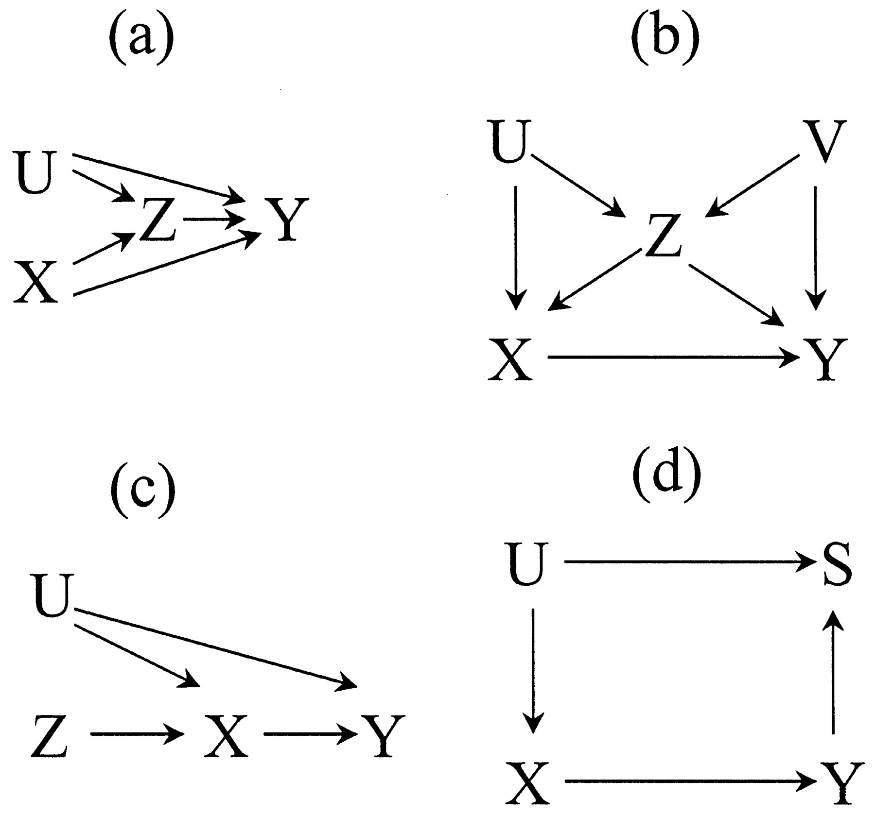

Figure 2: Four DAG examples

* 1. Write down all backdoor paths from X to Y and indicate whether they are open or closed.
  2. Write down a conditioning strategy that satisfies the backdoor criterion. If one does not exist, what is stopping it?

1. I have provided an example for using estout to do this in the /estout subdirectory on github in a file called ols.do, but note that it only creates a LaTeX file. If you want to create something for Word, you will need to use the .rtf format most likely. Read the estout help file online or at Stata.
2. Lawler, et al. (2005), “The Unique Effects of Forgiveness on Health: An Exploration of Pathways”, Journal of Behavioral Medicine, vol. 28 (2) April, pp. 157-167.